**Samples Orders Reports Invoices**

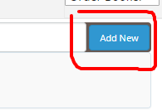

After booking the sample next we need to add order of the customer on this section with following details.

**Step 1:**

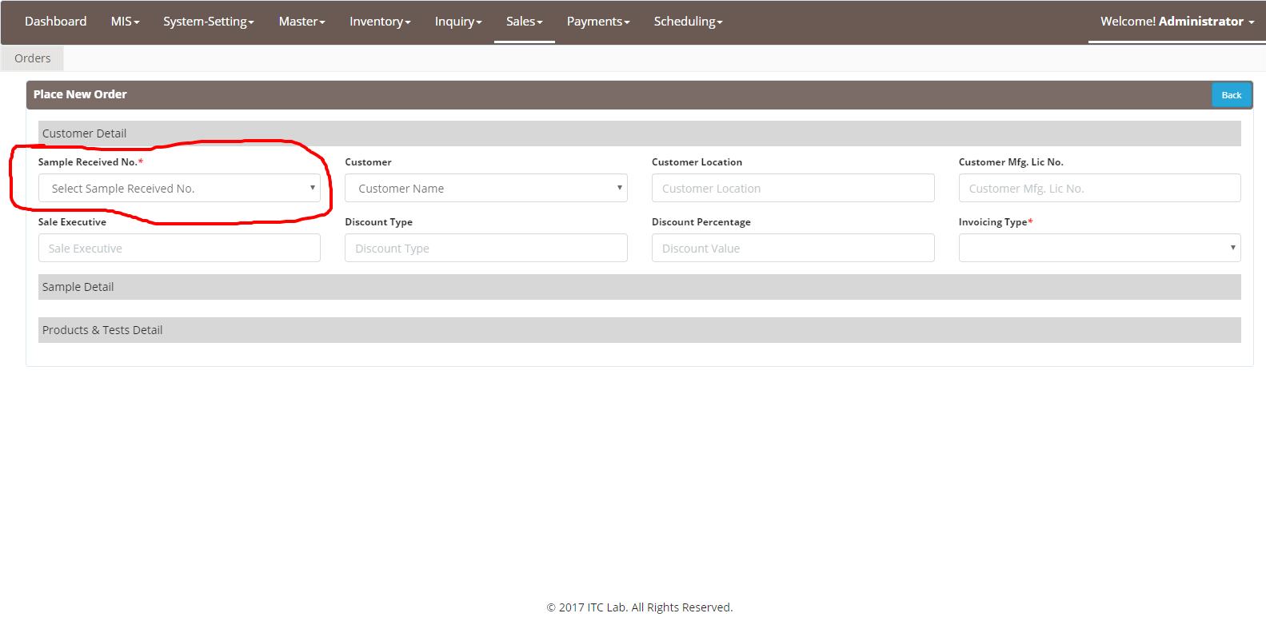

Need to select sample receive number: sample no will be alpha numeric value, first character will be the department name first character followed by the Year-Month-Date-S (sample) then number than backslash (/) than customer number than backslash (/) customer location.

F-180103S002/Customer Name/Customer Location.

**For Internal Transfer**

Sometimes when order booker book the order, there are some other department sample is there, suppose if food department person receive a sample and pharama sample also on the same package then user need the click the internal transfer tab and then select the category from the dropdown list and transfer the sample to the other department.

**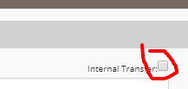**Than from the dropdown list select the department

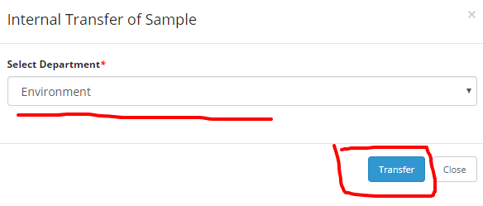

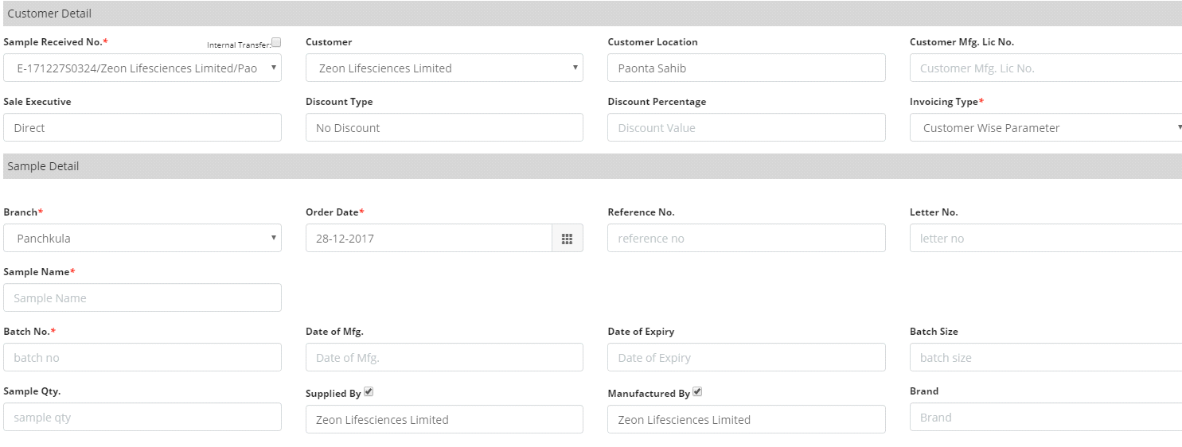

**Mandatory Parameters**

**Sample Name*\****

**Batch No.*\****

**Order Date*\****

**Sample Priority*\****

**Sealed/Unsealed*\****

**Submission Type *\****

**Signed/Unsigned*\****

**Packing Mode*\****

**Customer Mfg. Lic No.**

Sample name will be appear from the sample added in the master section and in autosuggestion it display the product otherwise we need to add the sample here.

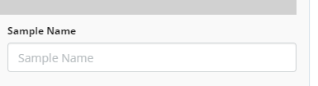

**Customer Mfg. Lic No.\*** provided by the customer

Sample sealed or unsealed and signed or unsigned selection based on the sample received by the sampler.

*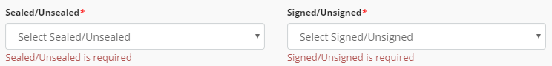*

**Submission Type** selection is mandatory and need to select sample submission type direct, courier and by sales person.

**Step 2(Optional):**

**Extra Details:**

Also provided the extra details options,

*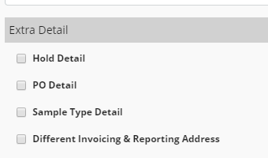*

Sometime order booker need to hold the order

*hole_reason.png*

Than customer order put on hold from here and order status will be hold.

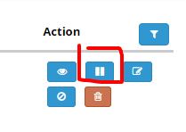

And after click on that icon user can unhold the order.

**PO Details:**

****

These details provided by the customer itself. Both PO no and PO date written on the PO provided by the customer.

**Sample Type Details:**

sampe_type_details.png

Inner laboratory used for the internal purpose by the company and for both inner laboratory and compensatory **no invoicing will generate.**



**Reporting to**: Customer can change the reporting address from this section

(I.e. sometimes customer wants the report on different address so he can do this by this section).

**Invoicing to:** Customer can change the invoicing address from this section.

Testing product section user need to select product category based product from the tree view.

**Step 3:**

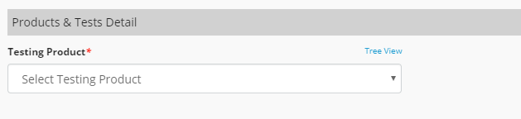

After selecting the product category wise product we can add the product from here.

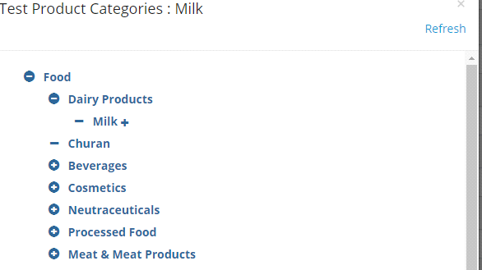

**Step 4:**

Than you can select testing product from testing product dropdown and also select the product tests.

****

And when you select Product testes name from the dropdown than popup will appear here.

**Step 5:**

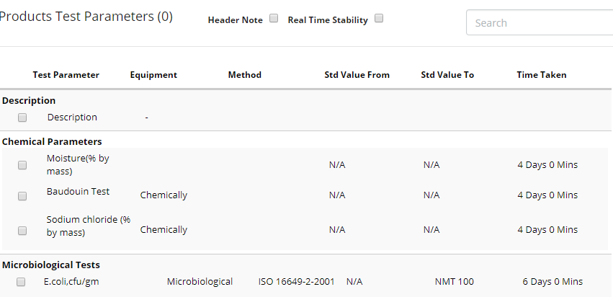

**Step 6:**

Than need to checked the test parameter according to the product and check/click the parameter which you want for the test.

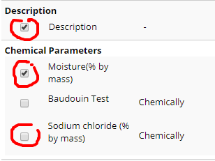

After that these test parameter will be added for the particular order

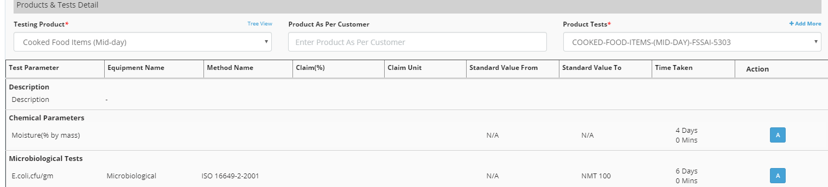

We can also add more parameter using add more button from the product tests section.

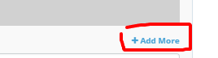

We can also select the alternative of the same product if alternative is available than user can select it.

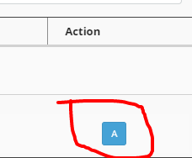

**Step 5:**

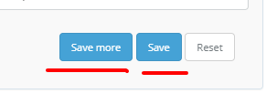

At last Click on save to save the order and if you have more order than you can add by using add more button.

User can view the booked order on the orders section like this-:



User can cancel the order from the actions options

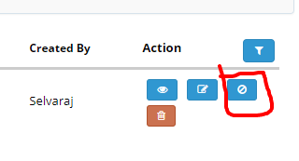

User can view the order

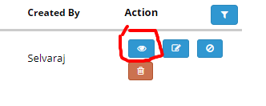

**Format of job order will be following.**

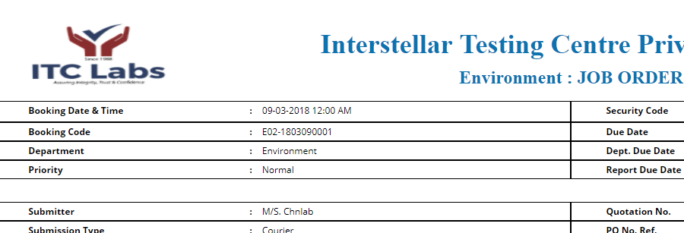

Booking person signature will appears on the last of the report.

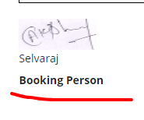

Also can generate the job order in the pdf format

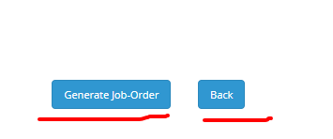

With party detail or without party details need to select

